
<Smart Graduation Project Management System>

Presented to the Faculty of Computer and Information Technology,
Jordan University of Science and Technology

In Partial Fulfillment
of the Requirements for the Degree of
Bachelor of Science in Computer Information Systems

By:
Ali ahmed ali saleh
Hamza eyad Mustafa al omari
Abdullah heider saed al swalmha
Obada zeid Mahmoud alkrnaz
Mohammad Safwan Mohammad Alsouliman

Supervised By:
Deya al-zoubi

Irbid, Jordan
Winter 2025

ABSTRACT

The ABC System is a development of a Smart Graduation Project Management System (SGPMS), a dedicated university website designed to modernize and streamline the current manual process for student graduation project and supervisor registration. The goal of the system was to create an online, centralized platform for university students to manage their graduation projects, replacing the outdated manual process.
The system created to be used by the students who are undertaking their final graduation projects ,the doctors (supervisors) who is the faculty members who mentor and oversee the student projects and the university administration (Department Heads) . The system created to be available a Web Application website which makes the system accessible at all times and anywhere by simply using a web browser and Internet connectivity.
This research project present the main steps that led to the creation of the system, starting from gathering data about different reporting systems that were available on the Internet and reviewing them. Then, specifying the requirements using Use Case analysis method that was needed to accomplish the design and development phase of the system. The last step was implementing the system.

ACKNOWLEDGEMENT
We are very thankful to everyone who supported us complete this paper effectively. We would like to thank our advisor Dr. Deya Alzoubi for his invaluable guidance, expert technical advice which were critical in shaping the direction and academic rigor of this paper.

Meeting timeline table with doctor Deya:
DURATION | DATE
Date | Activates | Time spent | supervisor signature
26/10/2025 | Initial Kick-off Meeting | 1 hour
4/11/2025 (online) | Requirement Analysis | 1 hour
18/11/2025 | Literature Review | 1 hour
23/11/2025 (online) | Technical Specification | 1 hour
9/12/2025 (online) | System Modeling | 1 hour
30/12/2025 | Documentation Progress | 1 hour

Table of Contents
1 Introduction 8
1.1 Introduction 8
1.2 Background 9
1.3 Problem statement 10
1.4 Required tools 16
2 Literature review 19
2.1 Articles Background (Optional) 19
2.2 Tools background 20
3 Requirement analysis: 30
3.1 Introduction 30
3.2 Work progress 30
3.2.1 Business Requirements identification: 30
3.3 Data Flow 42
4 System Design 43
4.1 Introduction: 43
4.2 User interface design 43
4.2.1 Site Map 44
4.2.2 Story board 45
4.3 Data Model 56
5 Conclusion 59
5.1 Conclusion: 59
5.2 Difficulty faced: 59
5.3 Future Works: 61
6 Reference 62

List of Figures
Figure Name Page
Use Case diagram 17
ER diagram 21

List of Tables
Table Name Page
Use Case table 18

Introduction

Introduction
The process of managing university Graduation Projects is frequently hampered by manual workflows, administrative bottlenecks, and a lack of personalized guidance for students. for these reasons we plan on creating a web page for university students/professors and department heads to transform the manual process into a digitalized one. The transition from manual, paper-based administrative tasks to digitized, automated systems is a fundamental shift occurring across modern educational institutions. This transformation is particularly crucial in managing high-stakes academic processes, such as the coordination of Final Year Projects. which are mandatory components of most university curricula. Traditionally, the process of registering for a project, selecting a supervisor, tracking progress, and receiving initial guidance has been frequently hampered by manual workflows, administrative bottlenecks, and a lack of personalized guidance for students. The need for a sophisticated, centralized solution is driven by several factors: the increasing size of students, the complexity of aligning student interests and expertise with faculty specializations, and the administrative burden placed on academic staff. An effective system must not only streamline the administrative workflow—handling registration, load balancing, and scheduling—but also significantly enhance the student experience by providing proactive, intelligent support. our project, titled the "SMART" Graduation Project Management System, focuses specifically on the "SMART" aspect of this digital transformation. Unlike traditional management portals that serve only as digital filing cabinets, this system integrates Artificial Intelligence (AI) and machine learning tools to act as an intelligent advisor. By leveraging an AI chatbot for personalized project suggestions, and automated project evaluation modules, the platform moves beyond simple coordination. It transforms the graduation project lifecycle into a smart decision-support ecosystem that bridges the gap between a student's technical expertise and the university's academic requirements.

1.2 Background
The process of initiating, managing, and executing graduation (final year) projects in many universities remains largely manual and decentralized. Students often face significant challenges in identifying a relevant and feasible project idea that aligns with their interests, expertise, and current academic knowledge. Furthermore, the selection of a suitable academic supervisor ("doctor") is often an arbitrary process, leading to mismatches in expertise and overloaded faculty members.

Problem statement
The current university process for graduation project management is inefficient, manual, and lacks personalized, intelligent support, resulting in barriers for both students and faculty. This traditional approach relies heavily on physical paperwork, decentralized spreadsheets, and informal communication, which leads to several critical issues:
- Administrative Bottlenecks: Manual registration and supervisor allocation often lead to uneven workloads among faculty and delays in project approvals.
- Information Asymmetry: Students frequently struggle to identify available supervisors or understand the current capacity of different departments, leading to frustration and wasted time.
- Lack of Creative Guidance: Many students face "blank page syndrome," where they struggle to translate their academic major and personal hobbies into viable, research-backed project ideas without significant one-on-one faculty intervention.
By failing to utilize modern computational tools, the existing process remains a purely administrative hurdle rather than a "SMART" academic journey that actively fosters innovation and efficiency.

Importance of the project
This project is crucial because it addresses critical inefficiencies in academic management and learning support by leveraging digital transformation and Artificial Intelligence to help the students with generating graduation project ideas.

Required tools
We plan on using:

Microsoft SQL Server:
It is a Relational Database Management System (RDMS) that uses the Structured Query Language SQL to access and manipulate stored data developed by Microsoft. It is a software product whose primary function is to store and retrieve data as requested by other software applications. Its scope includes data query and data update, schema creation and modification and data access control. In SQL server, the RDMS is integrated within the visual studio IDE to simplify data access from windows applications. (About Microsoft SQL, 2012).we plan on using it to save the login credintels of the students,doctors and department heads.

Microsoft visual studio code :
Microsoft Visual Studio is an integrated development environment (IDE) from Microsoft. It is used to develop console and graphical user interface applications along with Windows Forms applications, web sites, web applications, and web services in both native code together with managed code for all platforms supported by Microsoft Windows, Windows Mobile, Windows CE,.NET Framework, .NET Compact Framework and Microsoft Silverlight. (What is Visual Studio?, 2012).we will use this IDE to write our code on such as the web app using(html/css/JS/react/node.js).

Google colab:

Google Colab is essentially an online Jupyter Notebook hosted on Google’s servers. You can write text, run Python code, generate charts, train models, and store files. we will use this platform to write our AI model that will help suggest project ideas using python.

1.5.4 Socket IO:
A socket is a connection between two devices that allows them to send messages to each other instantly. this will help us with the group meeting system where we want the project doctor to have weekly meetings with the students.

Literature review

Research Articles
An article titled "GPMS: An educational supportive graduation project management system," describes the development of an innovative online system designed to manage all educational processes related to senior and graduate projects. The system aims to simplify challenging tasks for students and educators, ranging from project selection and creating rubrics to scheduling, report submission, grading, and final assessment. The methodology implemented is based on open-source technologies, specifically Java, Apache/Tomcat, WEKA (for data analysis), and MySQL DBMS, highlighting its flexibility and configurability for most colleges. The dataset is the real-time project-related information and web log data collected within the system, which is used by a data analytic gadget to monitor students' and teachers' pedagogical habits. The overall results and contributions include providing a centralized, intelligent platform that reduces chaos, minimizes manual errors, facilitates collaboration, and offers valuable insights to improve the quality of education. The system's architecture and technical details are presented to serve as a model for organizations seeking to enhance their final year project management. [https://www.researchgate.net/publication/318152919_GPMS_An_educational_supportive_graduation_project_management_system?fbclid=IwY2xjawOMWlxleHRuA2FlbQIxMQBzcnRjBmFwcF9pZAEwAAEemFyA3ipQ_B3EF0tPZB_wbd8SPI5M-uvaxdLdZgL2-ORVb58j-a8gxOEdKDk_aem_qYHAdmJ0XmbhSpQKNlswPA]

https://faculty.uaeu.ac.ae/mamoun_awad/GPMS/ -This website is similar to our project idea we want to create provided hosts the Graduation Project Management System (GPMS) for the United Arab Emirates University (UAEU). It is an educational software platform designed to automate and streamline the lifecycle of senior graduation projects for undergraduate students.The system is designed to replace manual processes with a centralized digital repository and management tool. The system was developed by Dr. Mamoun Awad and his team at UAEU's College of Information Technology. It is built on a standard 3-tier architecture using open-source technologies (Java, MySQL, and Apache/Tomcat) to ensure it is flexible and adaptable for different university departments.
While these papers/projects share our core idea we hope to differentiate ourselves from them by being focused on our JUST university specifically and offers many features that are not implemented such as using an AI Chatbot to proactively suggest project ideas based on personal interests and expertise, rather than just hosting a static list of proposals. and while GPMS uses WEKA for analyzing habits and facilitating grading through rubrics, your system implements an AI project review module that provides students with automated ratings and factor-based evaluations. Our platform acts as a smart decision-support system that bridges the gap between technical expertise and academic requirements, moving beyond the standard 3-tier management architecture used by traditional systems.

Tools Background
The tools we use such as SQL database to keep track of the students and other users as well as SOCKET IO which will help us with the doctors that plan on doing weekly online meetings with the students to keep track off their progress. What distinguishes our project from other (graduation project management systems)is that we specialize in or universities needs for example:our chatbot will provide previous students graduation projects from our university as a source of inspiration and reference as well as suggesting doctors and professor in our university that specialize/can help with the suggested graduation project.

Requirement analysis and specifications

Introduction:

The requirement analysis and specifications phase is one of the most critical stages in the software development process. It lays the foundation for the entire system by identifying what the users need, how the system should behave, and the constraints under which it must operate. In this project, requirement analysis focuses on understanding the needs of students, supervising doctors, and administrators within the graduation project management process, This chapter defines the system’s functional and non-functional requirements, describes the interactions between users and the platform, and establishes the specifications that guide the design and development of the system.

Work progress:
Requirement Gathering & Analysis:
Met with students and supervisors to understand the existing manual registration process.
Identified pain points such as difficulty in finding suitable project ideas, unorganized communication with supervisors, and lack of centralized tracking.
Collected detailed requirements for:
-Student portal
-Doctor portal
-AI modules (project suggestion, slide-reading AI, project evaluation AI)
-Meeting scheduler and weekly progress tracker
-Created a Software Requirement Specification (SRS) document.

Business Requirements identification:

to gain a complete and detailed understanding of the system specifications, a rigorous requirements engineering process was undertaken. This involved extensive interviews and formal meetings with all key stakeholders across the university, including the Project Coordinator Committee, Faculty Advisors (Doctors), and a diverse sample of Graduating Students. The purpose of this system is to digitize and enhance the graduation project registration and supervision process within the university. The system aims to solve the current challenges in manual project selection, supervision assignment, communication, and project idea generation by introducing automation and AI-powered features.

User functional requirements:
Below are the User Functional Requirements (UFRs) for your project. These describe what the system must allow the user to do, We will have three types of users: students, supervisors, department head

1. User Authentication & Access Control
These requirements ensure that the system is secure and that users see only the data relevant to their roles.
- UFR-1: All users must be able to interact with the application using both mouse and keyboard inputs.
- UFR-2: The system must provide distinct login interfaces for students, supervisors, and the department head using provided credentials.
- UFR-3: The department head must be able to specify and manage user authorities (permissions).

2. Student Features & Project Registration
These requirements focus on the student's journey from finding a supervisor to tracking their work.
- UFR-4: Students must be able to view available supervisors for the current semester, including their research areas and current group capacity.
- UFR-5: Students must be able to fill out and submit a digital registration form to request a specific supervisor.
- UFR-6: Students must be able to track the status of their registration (Pending/Approved/Rejected) and their ongoing project milestones.
- UFR-7: Students must receive automated email notifications regarding any status changes or updates to their project.

3. Supervisor (Doctor) & Progress Management
These requirements allow faculty members to manage their assigned student groups.
- UFR-8: Supervisors must be able to view a centralized list of all project groups officially assigned to them.
- UFR-9: Supervisors must receive an automated notification immediately upon a new student group being assigned to them.
- UFR-10: Supervisors must be able to update project progress bars, log feedback, and set weekly meeting schedules for their groups.

4. Department Head & Administrative Oversight
These requirements provide the administrative control needed to oversee the entire department.
- UFR-11: The department head must be able to approve or reject student project registration requests.
- UFR-12: The department head must be able to manage the system database, including adding or removing students and updating the supervisor list.
- UFR-13: The department head must receive notifications for every new project submission.
- UFR-14: The system must allow the department head to monitor web pages and modify site structures if necessary.
- UFR-15: The department head must be able to generate comprehensive reports on pending, ongoing, completed, and rejected projects.
- UFR-16: The department head must have the authority to "close" or suspend a project's progress if inconveniences or troubles occur.
- UFR-17: The department head must be able to prepare and send invoices to supervisors as required by university policy.

5. "SMART" AI Features (Integration)
To fulfill the "SMART" title of your project, these specific AI functions are categorized here.
- UFR-18: The system must provide an AI Chatbot that suggests project ideas based on student major, skills, and hobbies.
- UFR-19: The system must provide an AI extension that analyzes course slides to generate relevant project suggestions.
- UFR-20: The system must include an AI evaluation module to review uploaded project files and provide an automated rating.

System Non-Functional Requirements:
This section presents other non-functional requirements to be taken into consideration when implementing the required application. In order to simplify the design, facilitate delivery of a demonstration application the following requirements and assumptions have been defined:

System Assumptions:

1. Academic & Administrative Constraints
These focus on the rules and structures provided by the university department.
- Supervisor Allocation: Each department is assumed to have a fixed, predefined number of supervisors (doctors) assigned for graduation project oversight.
- Supervisory Load: Each doctor can supervise a limited, predefined number of student groups as determined by the department.
- Project Structure: Each graduation project group is assigned to exactly one supervisor, and students can only belong to one group at a time.
- Workflow Stability: The system assumes that the department follows a structured graduation project workflow that does not change frequently.
- Capacity Limits: System limits (total students, supervisors, and max groups per doctor) remain constant unless manually updated by an admin.

2. User Roles & Data Integrity
These relate to how users interact with the system and the quality of the data they provide.
- Verified Accounts: It is assumed that all students are enrolled with verified university accounts and that their academic information is already stored in the database.
- Secure Access: All users must log in using university-provided credentials; anonymous or guest access is strictly prohibited.
- Data Accuracy: Students are assumed to provide honest and accurate information regarding their skills and interests for AI suggestions.
- User Responsibility: Students are responsible for monitoring deadlines and notifications, while all users are responsible for managing their own availability for meetings.
- Minimal Training: It is assumed that supervisors and department heads can navigate the system without requiring extensive technical training.

3. "SMART" AI System Boundaries
These define the scope and limitations of the AI components.
- Recommendation Only: AI-generated ideas are considered recommendations; the final authority for project approval remains with the supervisor or department head.
- Input-Based Logic: AI suggestions are strictly based on student-provided inputs (major, skills, interests) and existing system data.
- Data Samples: The system assumes that previous project samples used for AI reference are provided by the department and may be limited in number.

4. Technical & Infrastructure Requirements
These define the hardware, software, and connectivity needs for the system to function.
- Connectivity: All users are assumed to have stable internet access to interact with the web-based platform.
- Browser Compatibility: Access is assumed to be through modern web browsers that support HTML5, CSS3, and JavaScript.
- System Form Factor: The platform operates exclusively as a web system; no mobile application functionality is included in the current scope.
- Communication Limits: Notifications and reminders are primarily delivered through the system interface rather than integrated SMS or external email.
- File Support: Students are assumed to submit project files in standard supported formats such as PDF, DOCX, and PPTX.
- Performance: Response times for basic operations like login and registration are assumed to be within acceptable limits under normal usage.

Non-Functional Requirements:
Examples of Non-Functional Requirements:

- Portability: The system shall be easily and quickly deployed on any university-approved server or hosting environment without requiring major modifications
- Speed: The system shall load any selected page or feature (dashboard, supervisor list, student project page, meetings page) in no more than 3 seconds under normal conditions.
- Scalability: The system shall easily support future expansion, including the addition of new departments, new supervisors (doctors), more students, and new system features such as extra AI modules or additional project-management tools.
- Availability: There are two key concepts for availability when it comes to this system:
  - Hours of operation: The system should be available 24 hours a day, 7 days a week. Given that 2 hours on Friday will be scheduled for Maintenance.
  - Reliability. The system shall be reliable for all users (students, supervisors, and department heads) with an uptime of 99%.
- Capacity: The system shall handle the expected load of student registrations, supervisor interactions, project uploads, and meeting logs.
- Data currency: All data in the system (supervisor availability, project registration status, meeting updates, AI results) shall be updated in real time with no delays.
- Data retention: The system shall store only relevant data.
- Disaster recovery: The system should be able to recover from an outage, Regular backups shall ensure no loss of Student project files , supervisor data , meetings logs , AI recommendation history
- Error-handling: The system should be able to handle unexpected situations such as A student attempting to register with a full-capacity supervisor ,Invalid login attempts ,Missing required inputs
- Clear, user-friendly error messages shall guide the user
- Internationalization: The system shall be user-friendly for people from different backgrounds and languages, supporting at minimum English and Arabic.
- Logging The system shall log all critical activities, such as Student project registrations ,Supervisor approvals or rejections ,Meeting scheduling ,AI-related usage ,These logs help with troubleshooting and auditing.
- Security The system shall ensure Protection of student and supervisor personal data ,Secure authentication using university credentials ,Strict user-role permissions (student, doctor, department head) ,Prevention of unauthorized access to sensitive data or project files.
Upgradeability: The system shall allow easy replacement or upgrading of components (e.g., AI modules, interface components, backend services) without affecting the overall system functionality.

System functional requirements:
Examples of Functional Requirements:

- The system should display a welcome message and a login button for the user to get through the portal.
- The system should provide an interface were each student can log in using his university id and password.
- The system shall authenticate users and redirect them to their appropriate dashboards based on their role.
- The system shall allow users to log out at any time.
- The system shall restrict access to system features based on user roles (student / supervisor / department head).
- The system shall send notifications (email or in-system alerts) whenever important updates occur.
- The system shall store all data in a secure SQL Server database.
- The system shall allow students to log in using university credentials.
- The system shall allow students to select a supervisor for their graduation project.
- The system shall allow students to submit a project registration request to the department head.
- The system shall allow students to view the status of their registration request.
- The system shall allow students to upload project files (PDF, DOCX, PPTX, etc.).
- The system shall allow students to view weekly meeting schedules assigned by their supervisor.
- The system shall display the list of available supervisors, including :
-Their specialization
-Number of groups assigned
-Remaining capacity
- The system shall allow supervisors to update the progress of each group.

System Design

Introduction:
The key objective of this chapter is to provide a clear understanding of the system structure, behavior, and views of a system. In short, the data modeling presented by an ER diagram, and the user interface storyboard are included in this chapter in addition to other model seen below.

Use case diagram
A use case diagram is one of the behavioral diagrams defined by the Unified Modeling Language (UML) for the purpose of describing the functional behavior of the system from user point of view. A use case diagram shows a graphical overview of the system functions in terms of actors and their goals represented as use cases.
For example, the following diagram shows the use case diagram of some project of four main users: customer, sales representative, manager, and the warehouse representative. A use case diagram that combines all users is presented in this section.
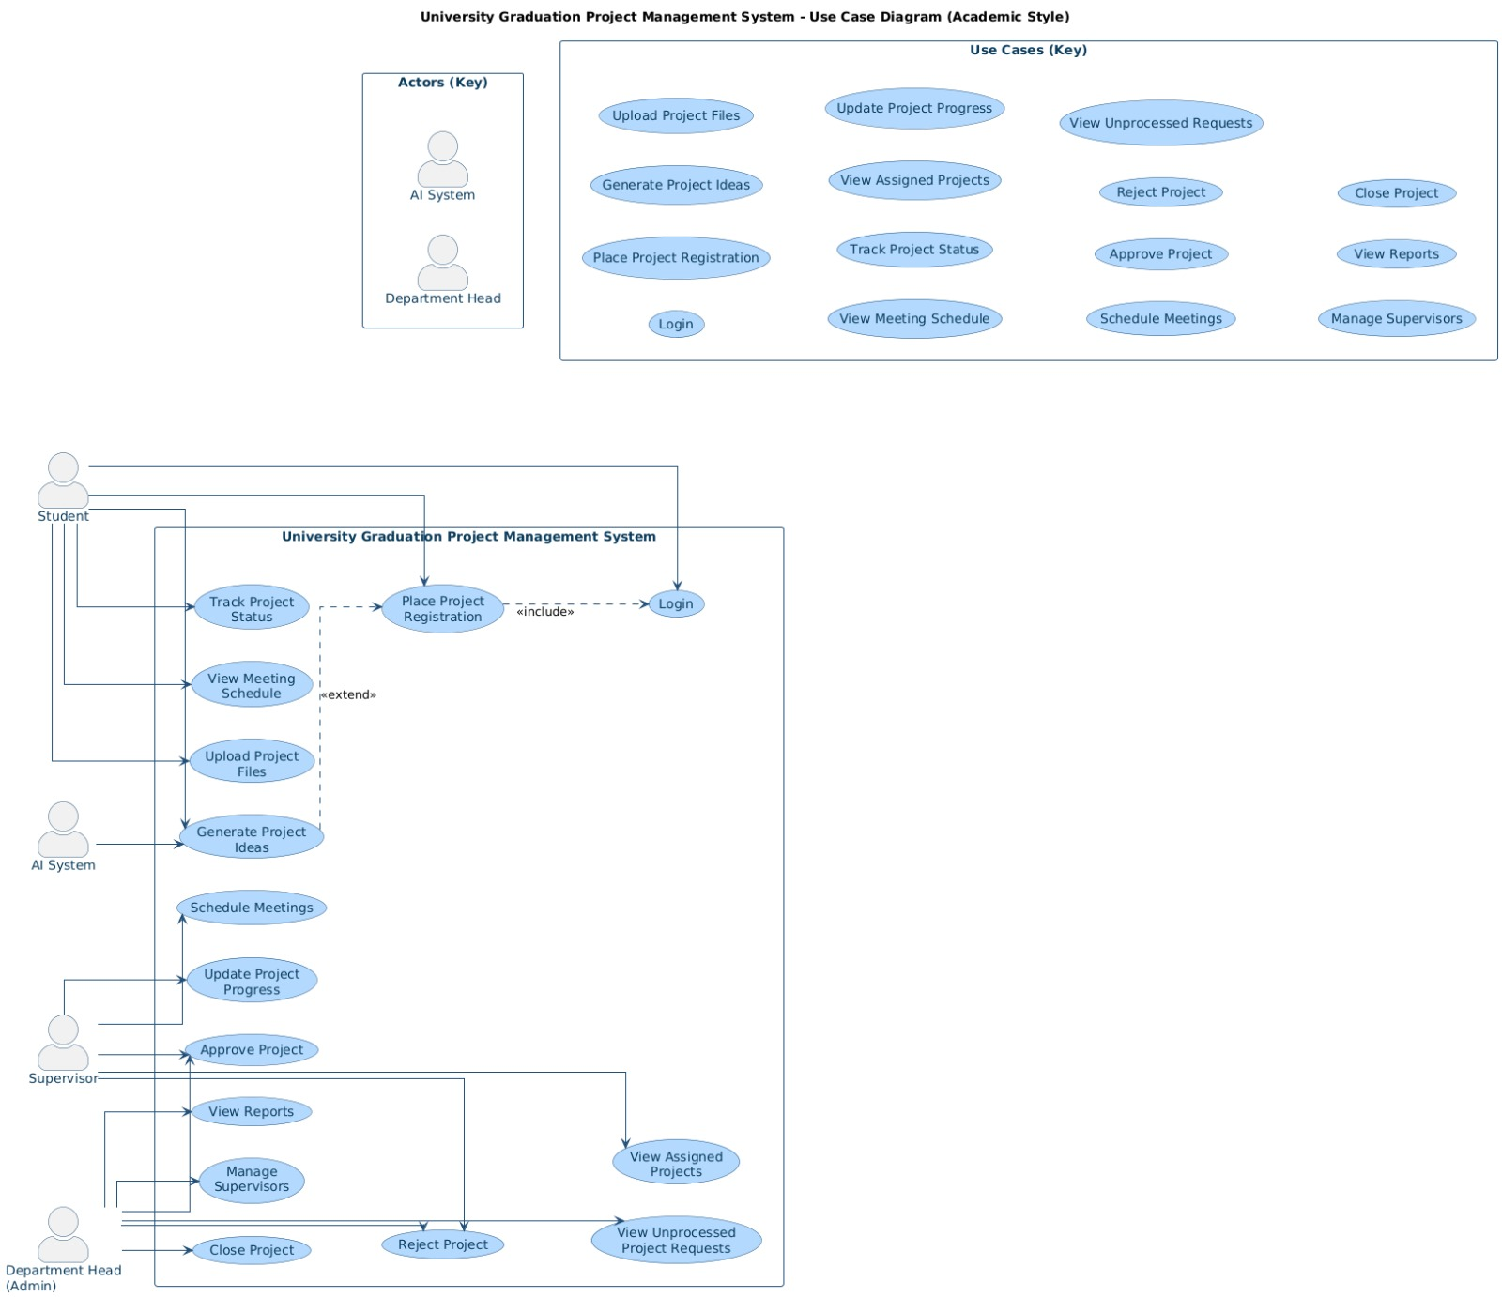
Figure 1 Use Case Diagram with Key

This system will include 5 different use cases shown in the Use Case Diagram above. These are:

Use case 1: Place Project Registration
Actor: Student | System / AI System
1. Student selects the "Place Project Registration" option from the student dashboard.  3. Student browses the list of available supervisors and selects a preferred doctor.  5- Student fills in the remaining required project details and clicks the "Submit" button. | 2- System displays the registration form, including fields for project title, description, and team member details.  4- System displays the selected supervisor’s details, including their research specialization and current remaining group capacity.  6- System validates the submitted data, saves the registration request in the database, and sends a notification to the Department Head for review.

Use case 2:Generate Project Ideas (AI System)
Actor: student | System/AI system
1- Student selects the "Generate Project Ideas" option from the AI Chatbot interface.  3- Student enters specific skills (e.g., Python, React) and expertise, then clicks the "Generate" button..  . | 2- System displays input fields requesting the student's academic major, technical skills, and personal interests.  4- AI System processes the input data using its recommendation engine to provide a list of tailored project titles and brief descriptions.  5- System displays the AI-generated suggestions along with links to articles, papers, and previous university projects for student reference.
Use Case 3: Approve/Reject Project
Actor: Department Head | System
1- Department Head (Admin) selects the "View Unprocessed Requests" option from the administration menu.  3- Department Head (Admin) identifies and selects a specific project request to view the full submission details.  5- Department Head (Admin) reviews the submission and clicks either "Approve" or "Reject" (providing comments if the request is rejected). | 2- System fetches and displays a list of all pending project registration requests awaiting review.  4- System opens the detailed request view, including the project title, descriptions, participating student names, and the chosen supervisor.  .6- System updates the project status in the database, formally assigns the group to the doctor’s supervisory load if approved, and sends automated notifications to the students and the selected supervisor.
Use Case 4: Schedule Meetings
Actor: Supervisor (Doctor) | System
1- Supervisor (Doctor) selects the "Schedule Meetings" option from the supervisor portal dashboard..  3- Supervisor (Doctor) selects a specific student group and enters the required details, including the date, time, and the meeting link or physical location..  5- Supervisor (Doctor) clicks the "Send Schedule" button to finalize the entry. | 2- System displays a list of all project groups currently assigned to that specific supervisor.  4- System saves the schedule in the database and automatically updates the "Meeting Calendar" visible to that specific student group.  6- System generates and sends an automated notification or email to all registered members of the selected student group...
Use Case 5: Update Project Progress
Actor: Supervisor (Doctor) | System
1- Supervisor (Doctor) selects the "Update Project Progress" option for a specific project group..  3- Supervisor (Doctor) enters the progresspercentage,provides qualitative feedback, or assigns grades for the current phase.  5- Supervisor (Doctor) clicks the "Save Changes" button to commit the update. | 2- System displays the current project status alongside a history of previous progress logs.  4- System updates the visual progress bar and saves the feedback and logs into the database.  6- System displays a success confirmation message and immediately updates the project view on the student's dashboard.

User interface design
This is a prototype of how our website interface will look like:
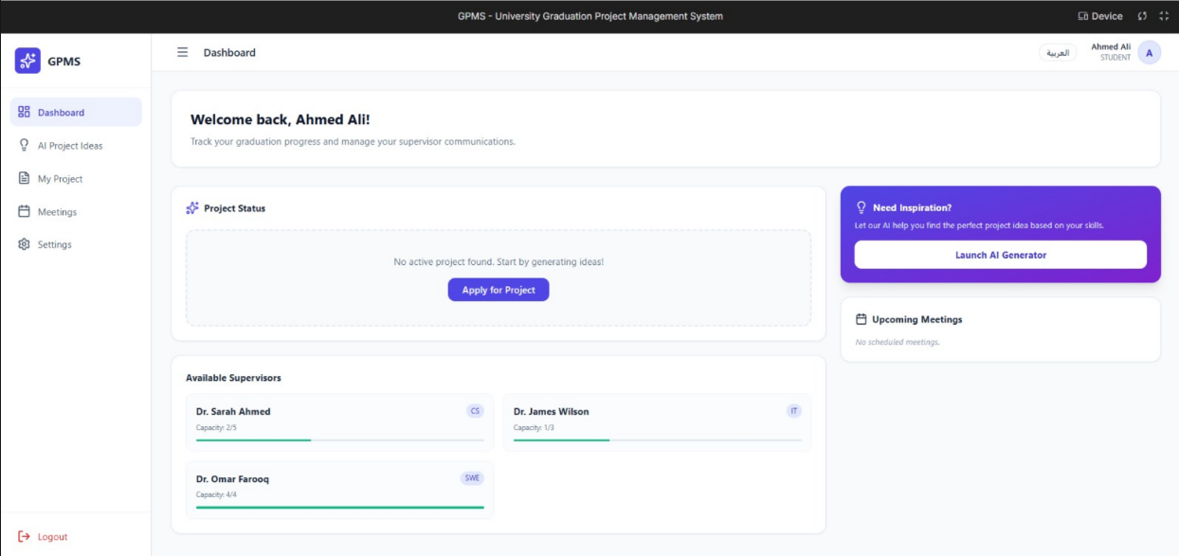
Student dashboard interface
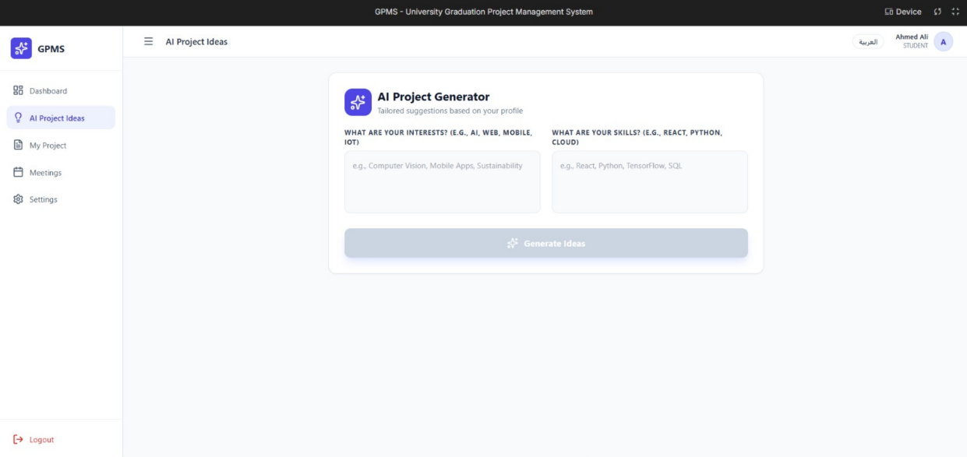
AI project generator interface

Data Model:

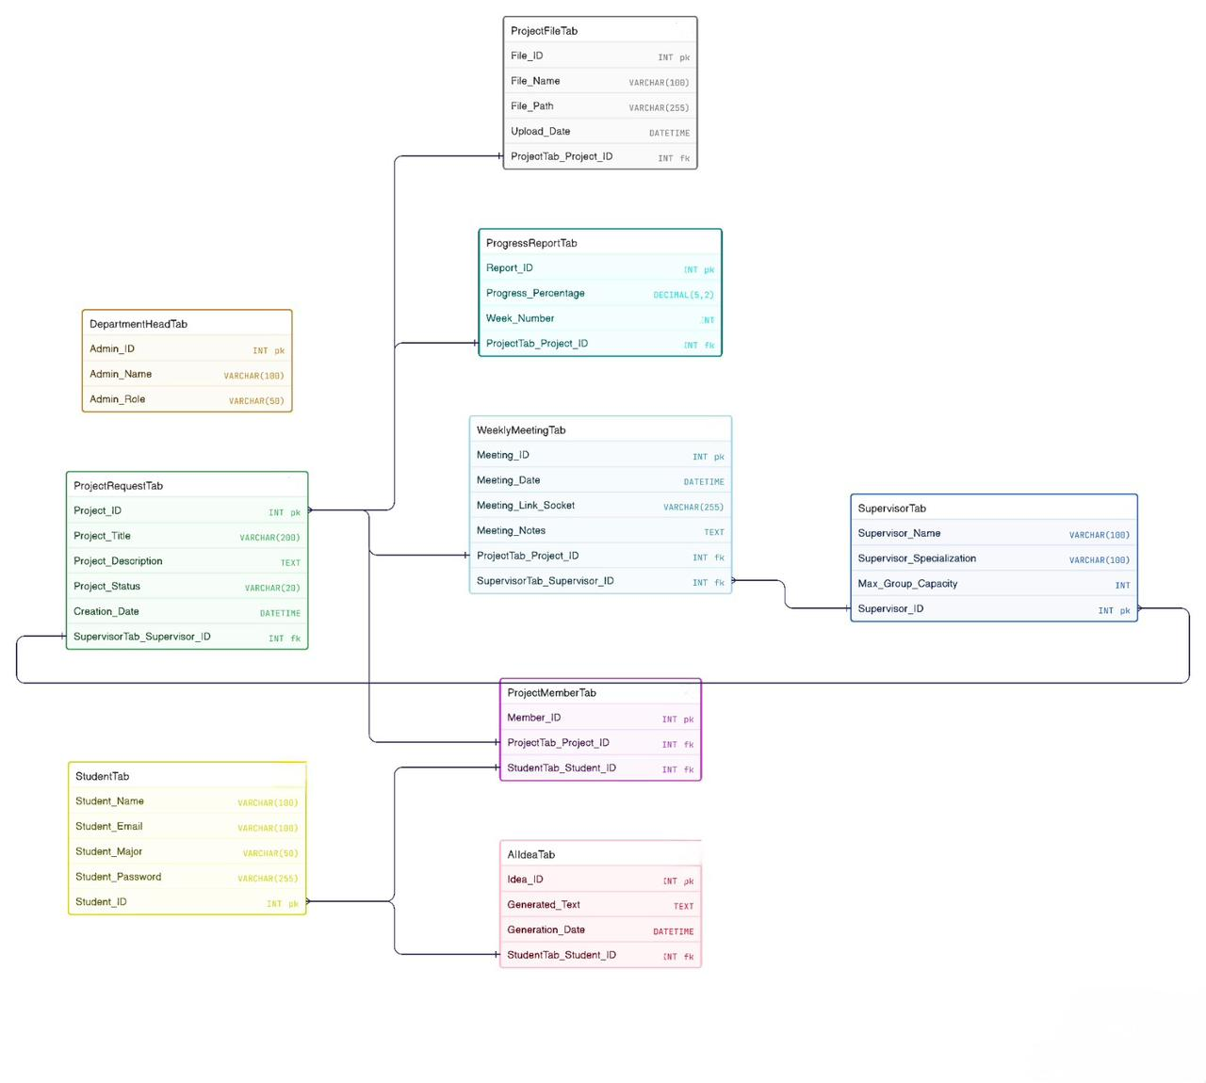
Figure 2 Entity Relationship Diagram

Conclusion

Conclusion:
The Smart Graduation Project Management System (SGPMS) was developed to modernize the academic workflow at Jordan University of Science and Technology. By transitioning from a manual, paper-based process to a centralized web application, the system effectively streamlines project registration and supervisor assignment. The integration of Artificial Intelligence provides students with personalized project ideas based on their skills and interests, addressing the common challenge of identifying feasible research topics.
The platform serves three primary user roles: students, supervisors (doctors), and department heads. For students, it provides tools to track progress and upload files. For supervisors, it offers features to manage student groups and schedule weekly meetings. For the administration, it grants full oversight through report generation and supervisor capacity management. Ultimately, this project reduces administrative bottlenecks and enhances the quality of the graduation project experience through digital transformation and intelligent support.

Difficulty faced:
During the development of this project, several challenges were encountered:
- Workflow Analysis: Analyzing and documenting the current manual workflow within the university department to ensure the digital system reflects real-world needs.
- Database Design: Defining complex relationships between entities, such as students, groups, and supervisors with limited capacities.
- Information Gathering: Finding specific data regarding existing systems and the necessary database structures to support AI modules.
- Interface Design: Creating a user-friendly and responsive interface suitable for different academic backgrounds.
- Time Management: Balancing the requirements of analysis, design, and implementation within the academic semester timeframe.

Future Works:
While the current version of the Smart Graduation Project Management System (SGPMS) provides a solid foundation for digitizing the graduation process, there are several enhancements planned for future iterations:
- Advanced AI Capabilities: Integrating more sophisticated AI modules, such as a "Slide-Reading AI" to help students prepare for presentations and a "Project Evaluation AI" to provide preliminary automated feedback on reports.
- Mobile Application: Developing a dedicated mobile app for iOS and Android to provide real-time push notifications for meeting reminders and status updates.
- Live Communication Tools: Enhancing the meeting system by integrating built-in video conferencing and real-time chat features using Socket.IO, moving beyond just scheduling.
- Plagiarism Detection: Integrating a plagiarism checking tool within the file upload system to ensure the academic integrity of submitted project files.
- Automated Document Generation: Adding a feature to automatically generate standardized final project reports and certificates based on the data stored in the system.
- Expanded Database: Scaling the system to include an "Alumni Database" where graduated students can share their experiences and full project documentation with current students

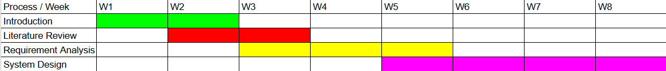

Gantt chart of timeline workflow

